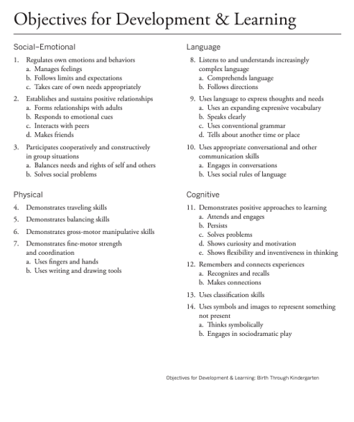

**LITERACY**

15. Demonstrates phonological awareness

a. Notices and discriminates rhyme

b. Notices and discriminates alliteration

c. Notices and discriminates smaller and smaller

units of sound

16. Demonstrates knowledge of the alphabet

a. Identifies and names letters

b. Uses letter–sound knowledge

17. Demonstrates knowledge of print and its uses

a. Uses and appreciates books

b. Uses print concepts

18. Comprehends and responds to books

and other texts

a. Interacts during read-alouds and book

conversations

b. Uses emergent reading skills

c. Retells stories

19. Demonstrates emergent writing skills

a. Writes name

b. Writes to convey meaning